***Class Diagram***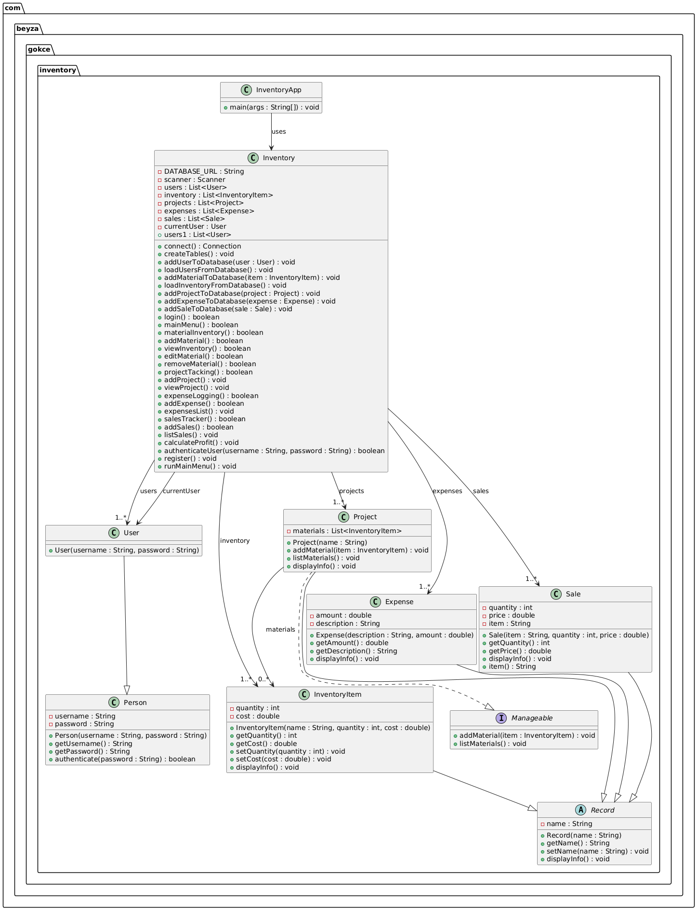

@startuml

package com.beyza.gokce.inventory {

abstract class Record {

- name : String

+ Record(name : String)

+ getName() : String

+ setName(name : String) : void

+ displayInfo() : void

}

class Person {

- username : String

- password : String

+ Person(username : String, password : String)

+ getUsername() : String

+ getPassword() : String

+ authenticate(password : String) : boolean

}

class User {

+ User(username : String, password : String)

}

class InventoryItem {

- quantity : int

- cost : double

+ InventoryItem(name : String, quantity : int, cost : double)

+ getQuantity() : int

+ getCost() : double

+ setQuantity(quantity : int) : void

+ setCost(cost : double) : void

+ displayInfo() : void

}

interface Manageable {

+ addMaterial(item : InventoryItem) : void

+ listMaterials() : void

}

class Project {

- materials : List<InventoryItem>

+ Project(name : String)

+ addMaterial(item : InventoryItem) : void

+ listMaterials() : void

+ displayInfo() : void

}

class Expense {

- amount : double

- description : String

+ Expense(description : String, amount : double)

+ getAmount() : double

+ getDescription() : String

+ displayInfo() : void

}

class Sale {

- quantity : int

- price : double

- item : String

+ Sale(item : String, quantity : int, price : double)

+ getQuantity() : int

+ getPrice() : double

+ displayInfo() : void

+ item() : String

}

class Inventory {

- DATABASE_URL : String

- scanner : Scanner

- users : List<User>

- inventory : List<InventoryItem>

- projects : List<Project>

- expenses : List<Expense>

- sales : List<Sale>

- currentUser : User

+ connect() : Connection

+ createTables() : void

+ addUserToDatabase(user : User) : void

+ loadUsersFromDatabase() : void

+ addMaterialToDatabase(item : InventoryItem) : void

+ loadInventoryFromDatabase() : void

+ addProjectToDatabase(project : Project) : void

+ addExpenseToDatabase(expense : Expense) : void

+ addSaleToDatabase(sale : Sale) : void

+ login() : boolean

+ mainMenu() : boolean

+ materialInventory() : boolean

+ addMaterial() : boolean

+ viewInventory() : boolean

+ editMaterial() : boolean

+ removeMaterial() : boolean

+ projectTacking() : boolean

+ addProject() : void

+ viewProject() : void

+ expenseLogging() : boolean

+ addExpense() : boolean

+ expensesList() : void

+ salesTracker() : boolean

+ addSales() : boolean

+ listSales() : void

+ calculateProfit() : void

+ authenticateUser(username : String, password : String) : boolean

+ register() : void

+ runMainMenu() : void

+ users1 : List<User>

}

class InventoryApp {

+ main(args : String[]) : void

}

' Inheritance

User --|> Person

InventoryItem --|> Record

Project --|> Record

Project ..|> Manageable

Expense --|> Record

Sale --|> Record

' Associations

Inventory --> "1..*" User : users

Inventory --> "1..*" InventoryItem : inventory

Inventory --> "1..*" Project : projects

Inventory --> "1..*" Expense : expenses

Inventory --> "1..*" Sale : sales

Inventory --> User : currentUser

Project --> "0..*" InventoryItem : materials

InventoryApp --> Inventory : uses

}

@enduml